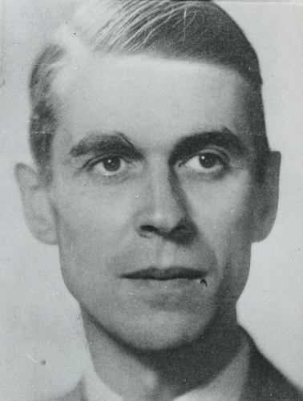
Walraven van Hall
His life
Walraven van Hall lived from 1906 till 1945. He was a banker and resistance leader during the occupation of the Netherlands in World War 2. He was born into an influential Dutch family. He studied economics and then he moved to New York in 1929, and he got a job in Wall Street. There he got his banking experience.
The war
After the German invasion, a fund was established to help families of merchant sailors, who were stranded abroad when war broke out. Soon thereafter, the Germans began taking anti-Jewish and forced labour measures; resistance agiainst these measures increased. Van Hall, who expanded his fundraising activities for all kids of resistance groups, became known as the banker to resistance.
The Dutch national bank was under control of the Germans, so the, with approval the Dutch government-in-exile, managed to obtain 50 millions Dutch guilders. Another way to acquire money was borrowing from wealthy Dutch people, as a proof of investment, they received old stock paper, but after the war, they could get the money back in exchange for stocks. He also support almost 900 hiding jews.
He was in charge of the National Support fund, he had a nickname Kern (Nucleos). The NSF supported a variety of resistance groups.
On 27 January 1945 was Teus van Vliet, founding member of the resistance, arrested by Gemans and tortured, as a result, the Germans led to several leading members of resistance, including van Hall. So he was executed, after war he was buried in Overveen in the Erebegraafplaats Bloemendaal.

